|  |  |  |
| --- | --- | --- |
| User Story | Notes | Acceptance Test(s) |
| Howard is looking for a new recipe that will challenge his skills | This is linked to the question I had about how best to categorise recipes. In Howard’s case it may be difficult for him to cook a recipe from a different culture | * Howard clicks on the categories page on the website * Howard clicks on a category he thinks will challenge him * Howard clicks on a dish he is not very familiar with |

* Howard clicks on the categories page on the website

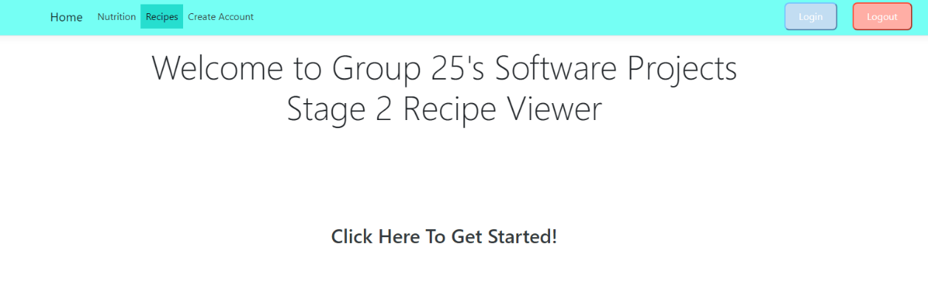

* Howard clicks on a category he thinks will challenge him

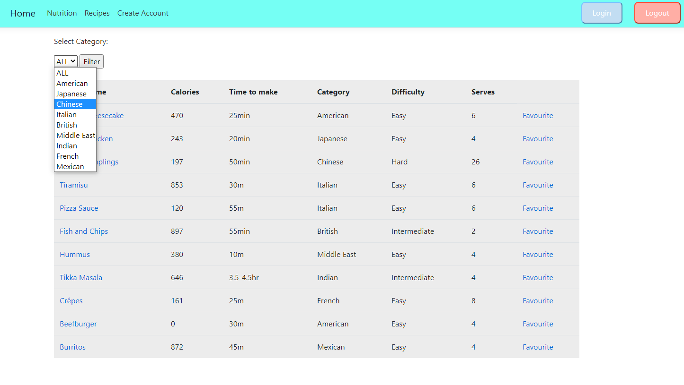

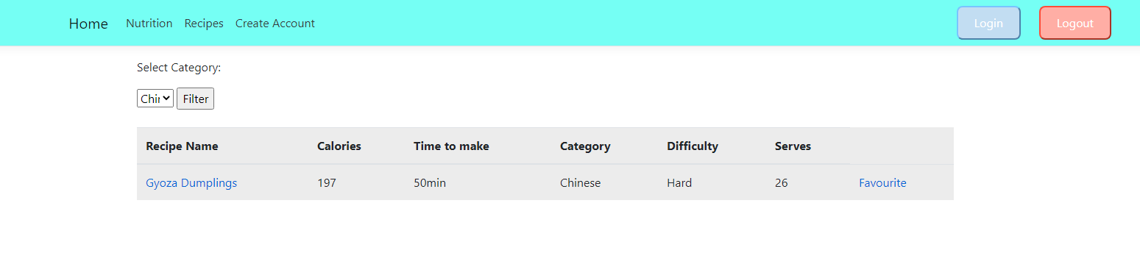

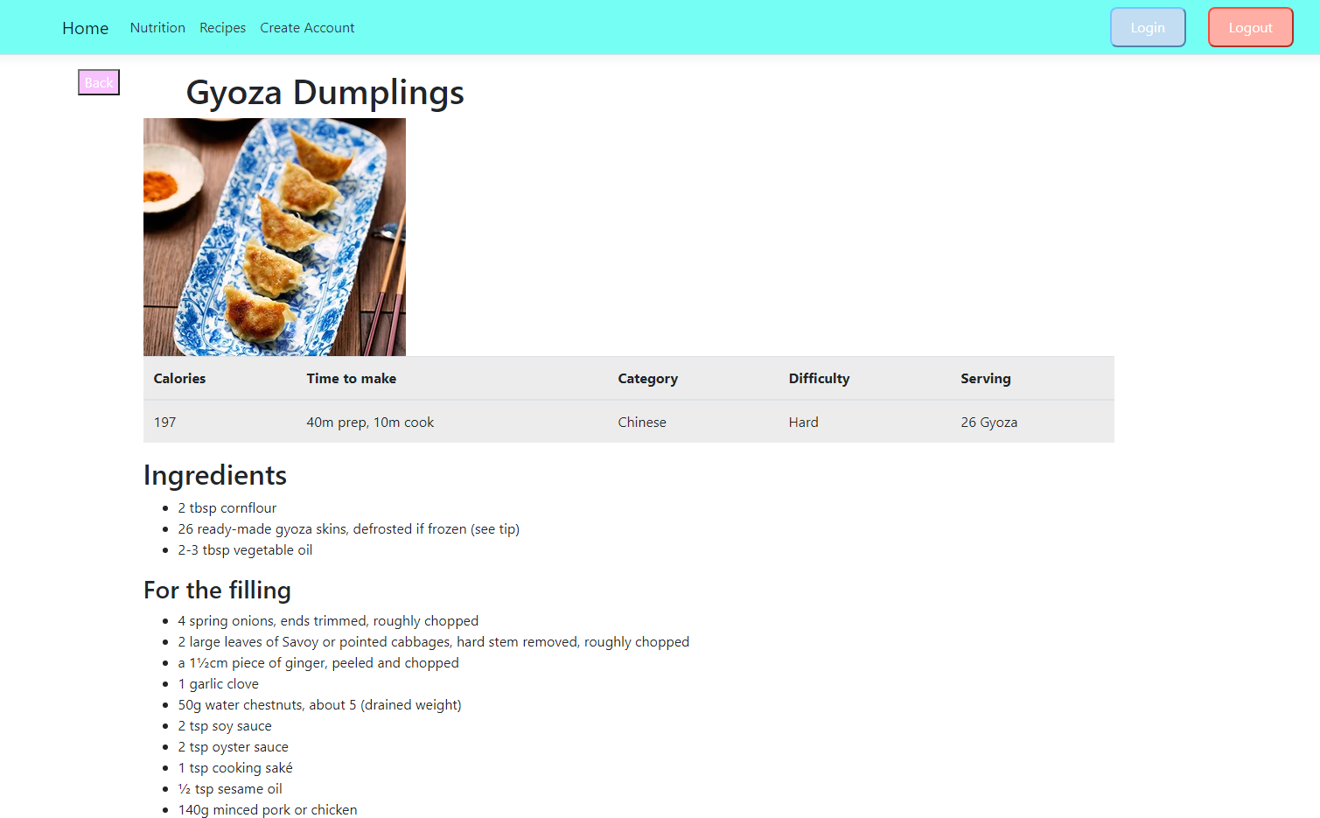

|  |  |  |
| --- | --- | --- |
| Howard enjoyed a recipe he tried and wishes to leave a positive comment on the page | User accounts should be required to leave comment as this deterrs anonymous users from leaving comments with ill intent | * Howard logs in to his account * Howard searches for the recipe he followed * Howard clicks on the recipes * Howard types his opinion into the comment box * Howard presses the button to send his comment |

We tried to get a comment system working on our page, however it was a lot harder than we anticipated and couldn’t get it working in time.

|  |  |  |
| --- | --- | --- |
| Howard wishes to favourite a recipe so he can easily access the page in future | This might not be 100% necessary however I think it would be a nice feature | * Howard makes his way to the page of the recipe he wishes to save * Howard clicks the favourite button * Howard checks his favourites and sees the recipe |

Same as commenting, we also found it difficult to add favourites and display it on the user page so we removed the functionality from the final product instead of having half working features.

|  |  |  |
| --- | --- | --- |
| Mike wishes to create a user account | User data is stored inside of a user table | * Mike clicks the create account button * Mike inputs his information * Mike clicks submit * Mike is able to login |

* Mike clicks the create account button

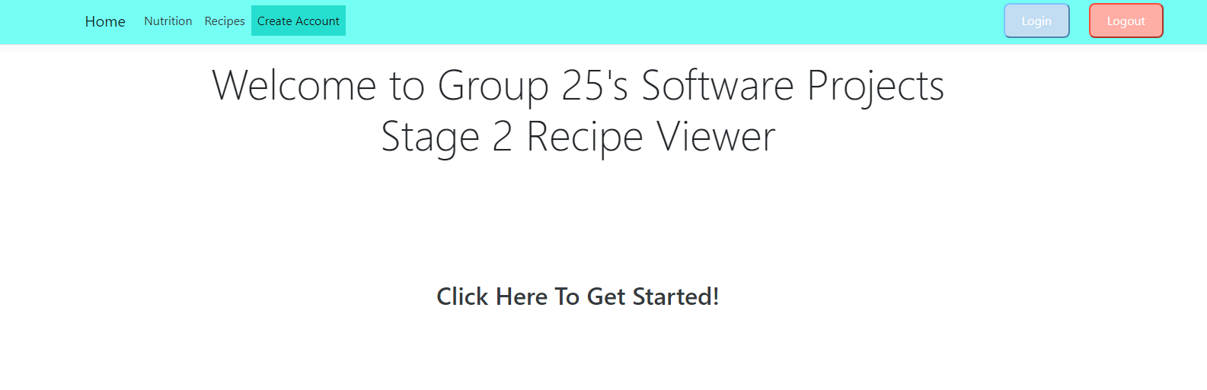

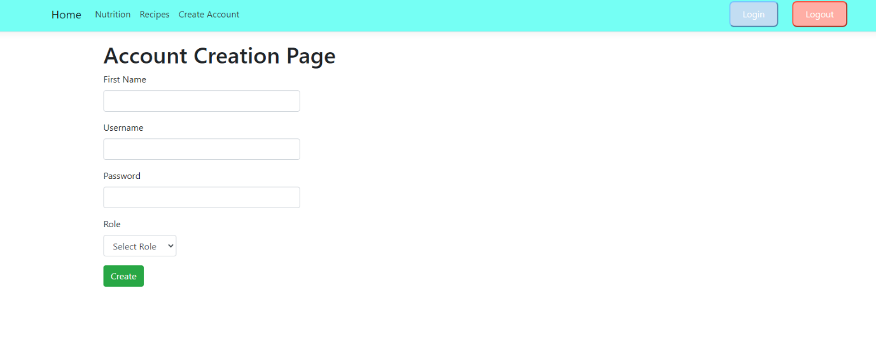

* Mike inputs his information

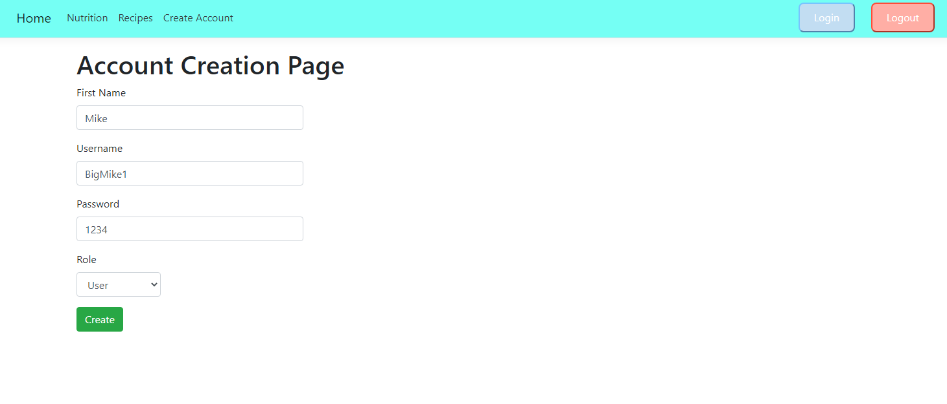

* Mike clicks submit

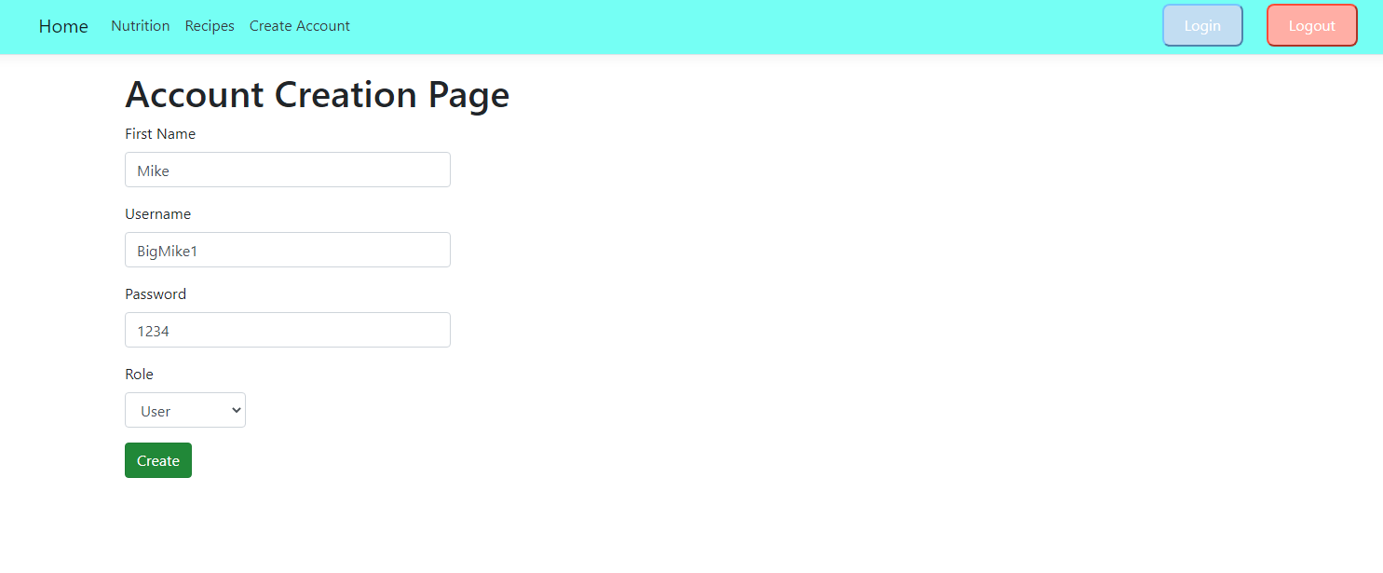

* Mike is able to login

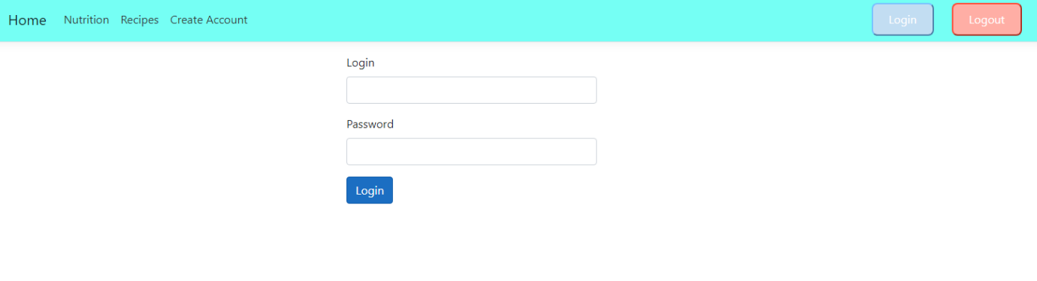

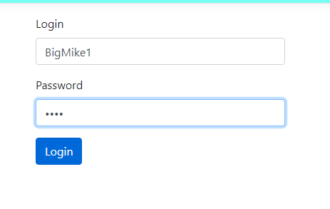

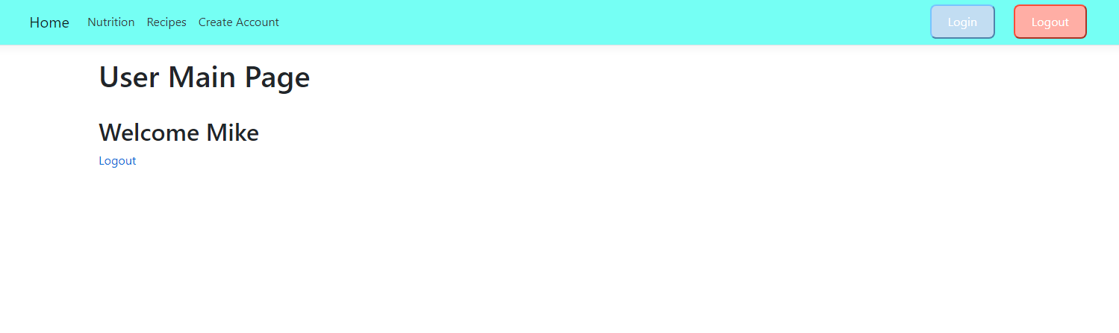

|  |  |  |
| --- | --- | --- |
| Mike wishes to learn more about nutrition |  | * Mike clicks on the Nutritional information page * Mike can read information about the different food groups |

* Mike clicks on the Nutritional information page

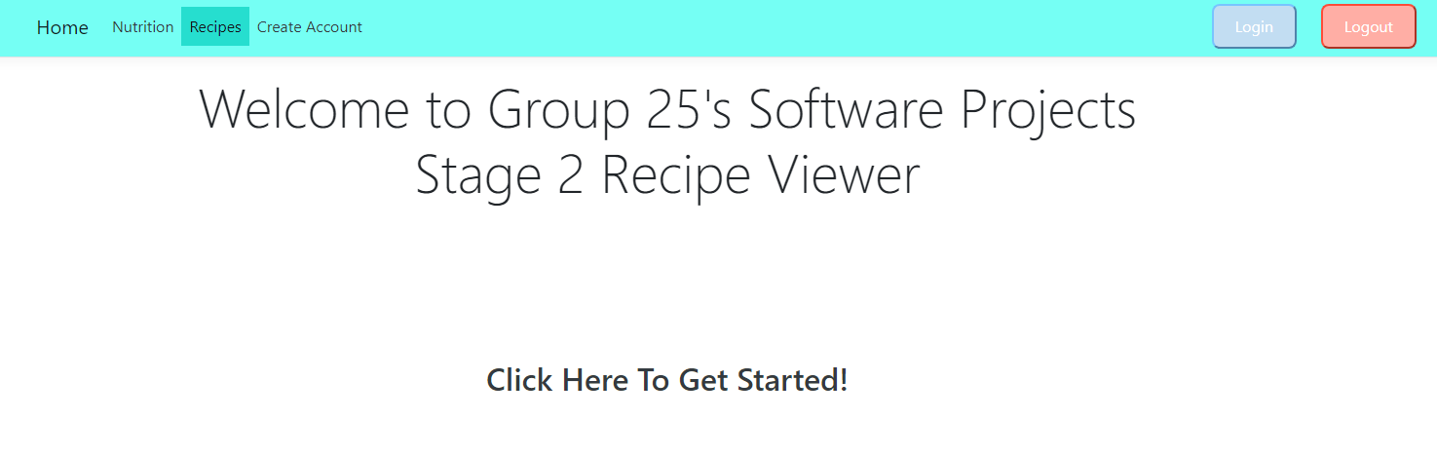

* Mike can read information about the different food groups

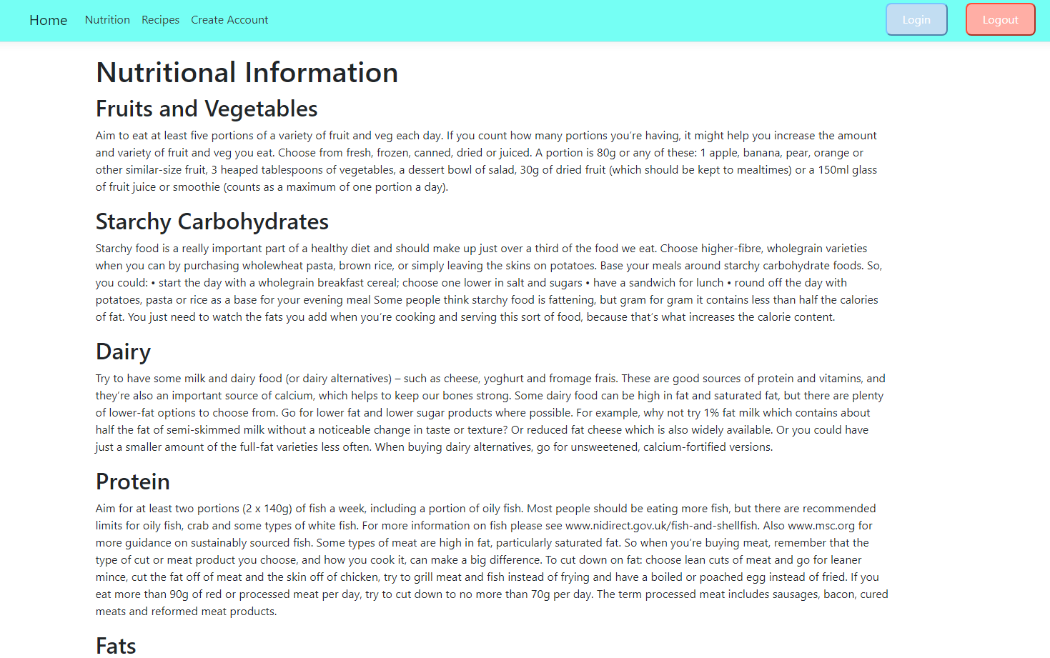

|  |  |  |
| --- | --- | --- |
| Kim notices an inappropriate comment left on a recipe by a user |  | * Kim logs into her account * Kim accesses page where user comments are displayed * Kim deletes the inappropriate comment |

Couldn’t get comments working as stated prior

|  |  |  |
| --- | --- | --- |
| Kim is notified of an error on one of the recipes | It may be appropriate for admins to have accounts with rights to modify pages inside of the website instead of having to alter the website code. This is what we are assuming here | * Kim logs in to the website in her admin account * Kim accesses the admin page * Kim makes her way to the recipe page with the error * Kim clicks the edit button and corrects the error * Kim saves the change * Kim refreshes the page and can see her changes |

* Kim logs in to the website in her admin account

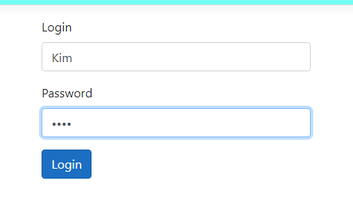

* Kim accesses the admin page

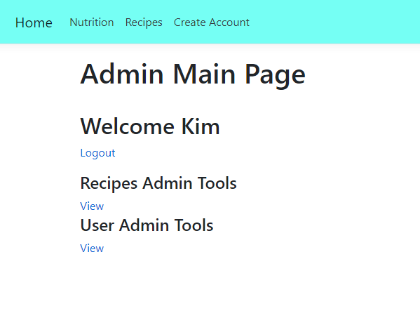

* Kim makes her way to the recipe page with the error

Instead of doing this, she clicks on the recipe tools instead and can see all of the recipes in the same place

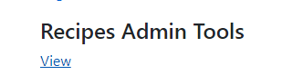

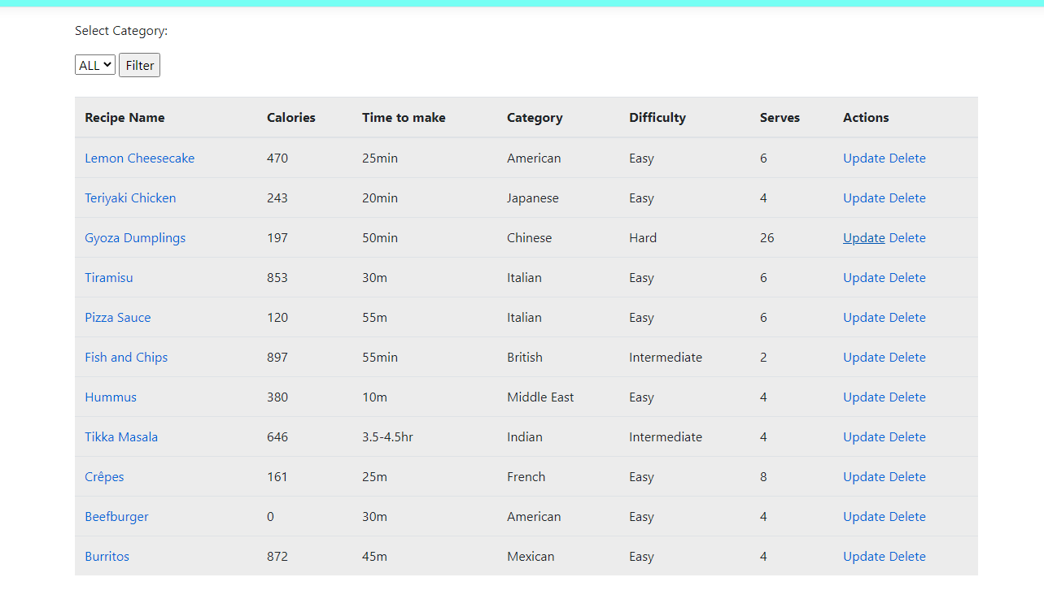

* Kim clicks the edit button and corrects the error



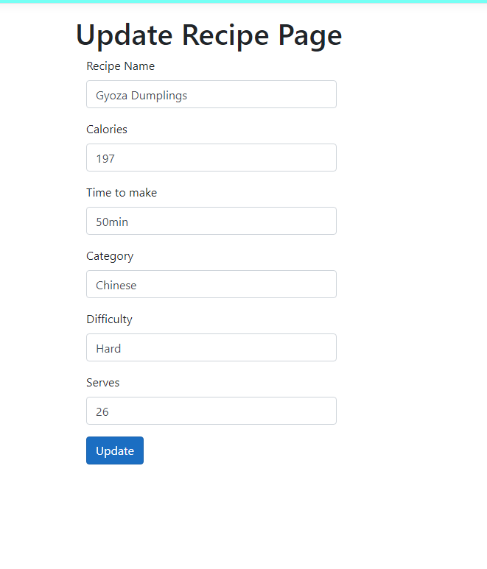

Lets say it serves 25 instead

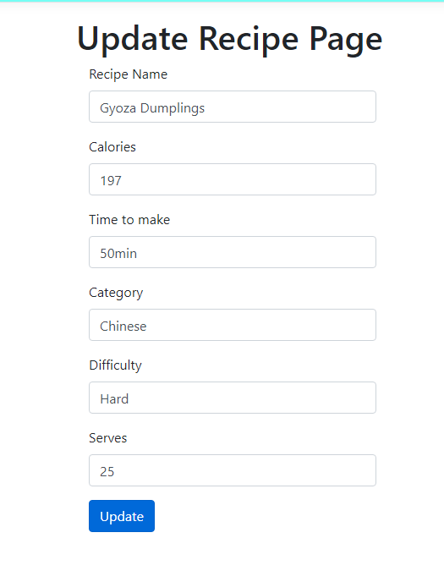

* Kim saves the change



* Kim refreshes the page and can see her changes

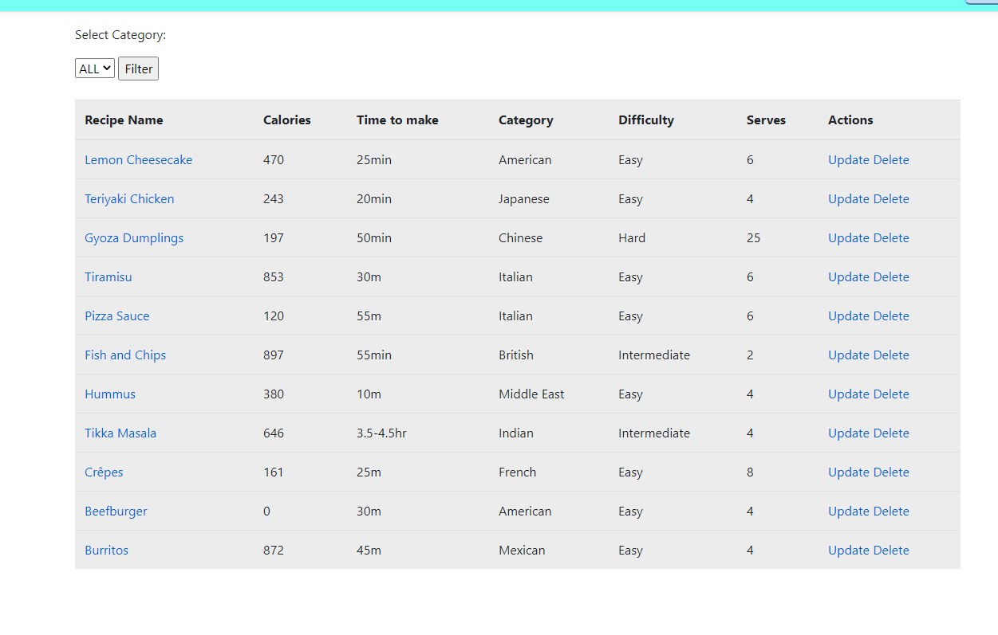

Instead of refreshing the page, she is brought back to the overview page after updating the recipe and can see that it now serves 25

|  |  |  |
| --- | --- | --- |
| Kim is informed that another admin does not have the appropriate rights | Only an admin can make another use an admin | * Kim logs into her admin account * Kim accesses the admin page * Kim accesses the user page * Kim sets the user role of the fellow admin to admin, instead of user * Kim saves the changes |

* Kim logs into her admin account
* Kim accesses the admin page

For brevity as I’ve displayed these in the previous acceptance test I will continue from The admin page

* Kim accesses the user page

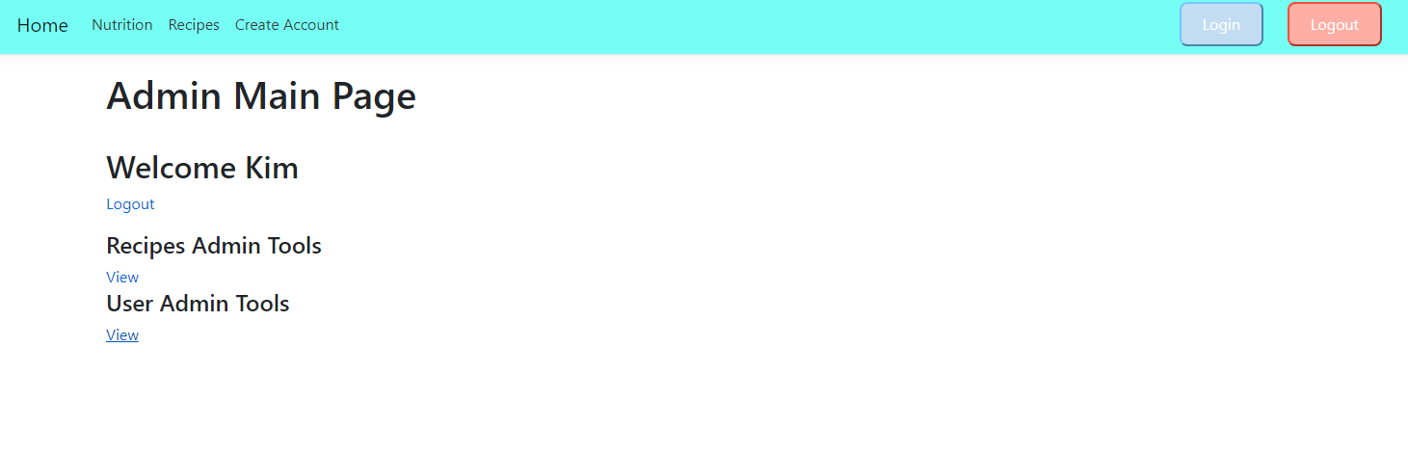

* Kim sets the user role of the fellow admin to admin, instead of user

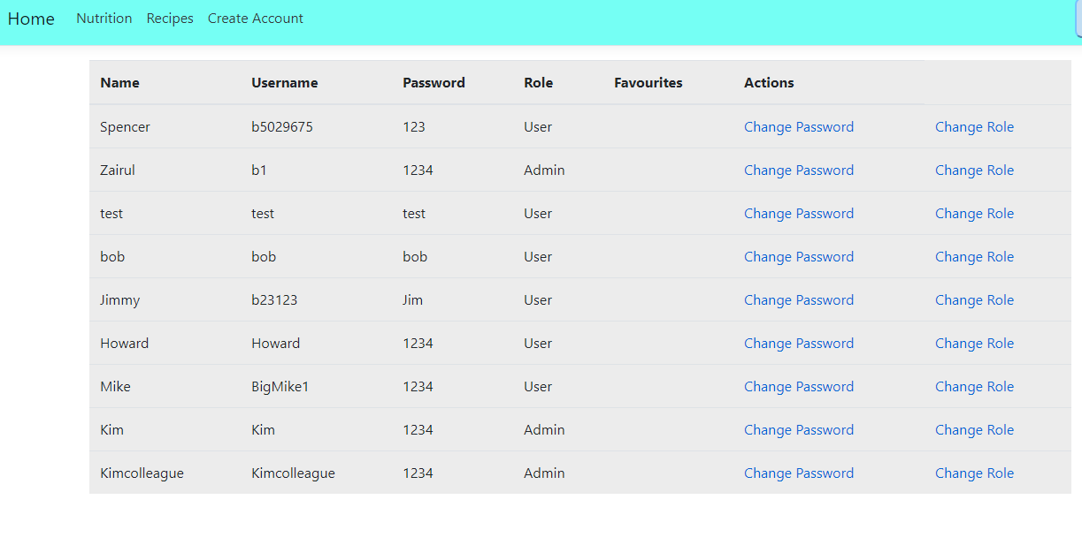

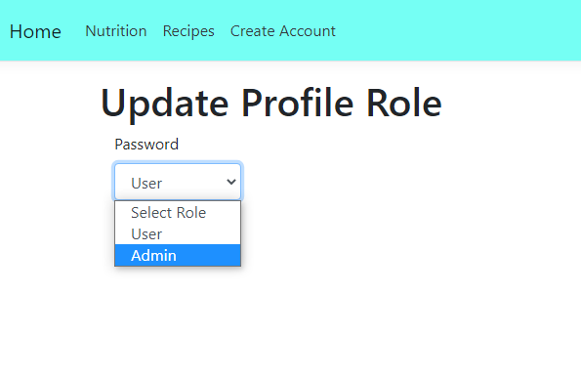

* Kim saves the changes

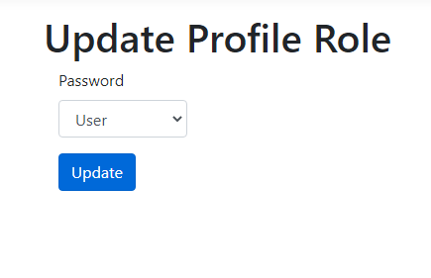

* Kim sees the role change for her colleague

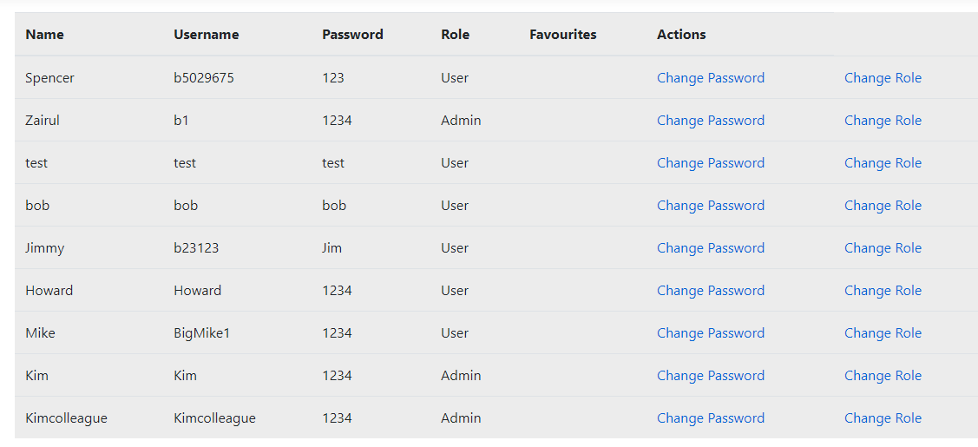

Kim is auto directed back to this page after pressing update

* Kim logs into her colleagues account to check they are an admin

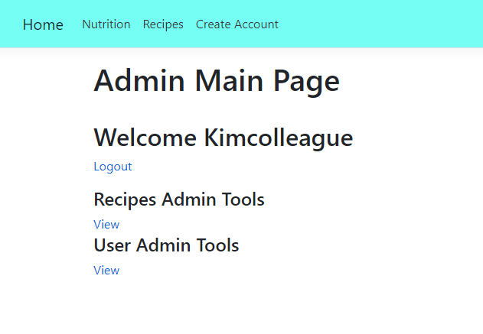

|  |  |  |
| --- | --- | --- |
| Kim is made aware of a user who has forgotten their password | Password recovery. While this is slow as the user has to contact this person, it is the only solution as there is not an email system in place | * Kim logs into her account * Kim makes her way to where user accounts are displayed for admins * Kim finds the user and sees the password displayed * Kim changes the user password and tells the user what the new password is. |

* Kim logs into her account
* Kim makes her way to where user accounts are displayed for admins

Again for brevity ill skip these as they have been showcased prior

* Kim finds the user and sees the password displayed

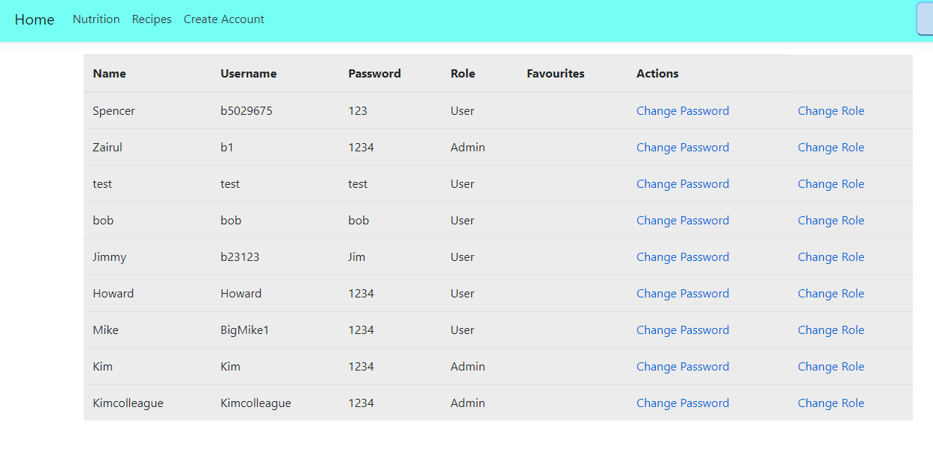

Lets say bob has forgotten his password

